# SNP statistics

1. SNP distribution

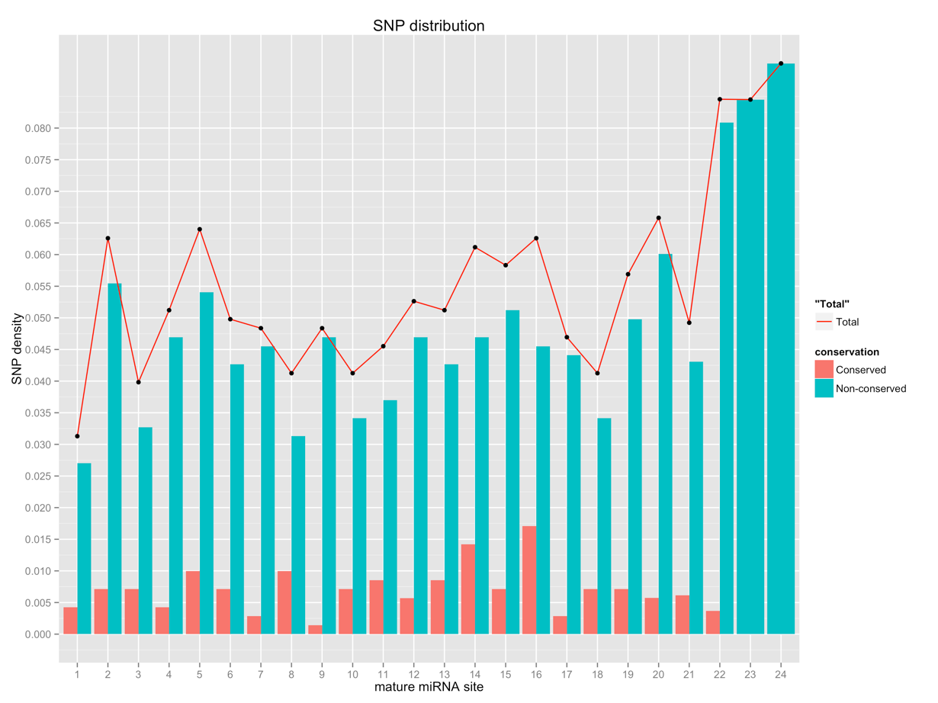

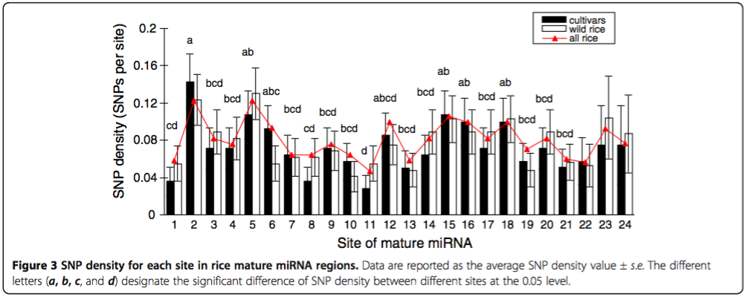

Illustration:

1. Upper graph is the plotting of SNP density query of 3K Rice SNP-seek database;
2. Lower graph is the one published in *Rice* journal.

Summary of upper graph:

1. In total
   1. Position **(22, 23, 24, 20, 5)** have the highest SNP densities which are 0.08455882, 0.08450704, 0.09022556, 0.06580830, 0.06401138 separately;
   2. While position **(1, 3, 8, 10, 18)** have the lowest SNP densities, and their densities are (0.03129445, 0.03982930, 0.04125178, 0.04125178, 0.04125178);
2. In conserved
   1. Position **(14, 16)** whose densities are (0.014224751, 0.017069701) (highest);
   2. Position **(7, 9)** whose densities are (0.002844950, 0.001422475) (lowest);
3. In non-conserved
   1. Position **(22, 23, 24, 20, 2)** whose densities are (0.080882353, 0.084507042, 0.090225564, 0.060085837, 0.055476529) (highest);
   2. Position **(1, 8)** whose densities are (0.027027027, 0.031294452) (lowest);
4. miRNA SNP density distribution

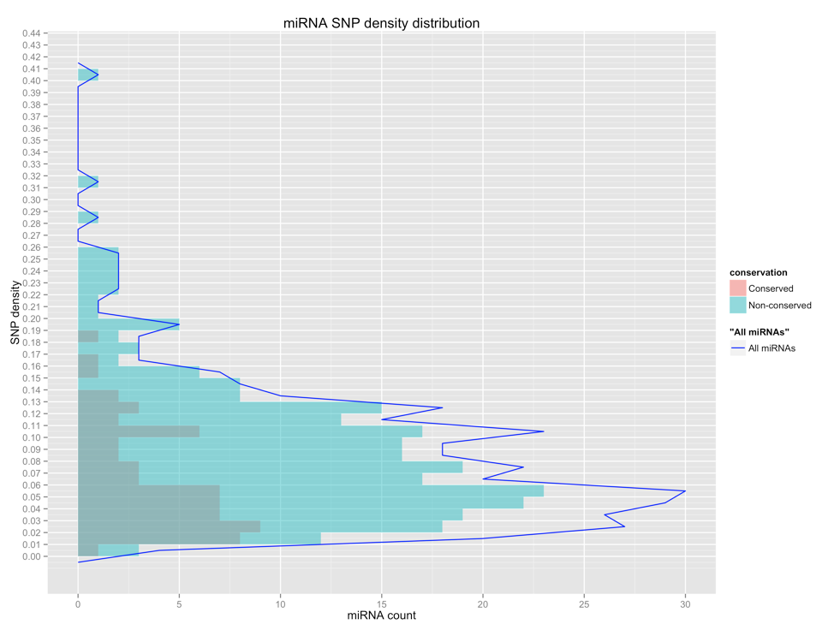

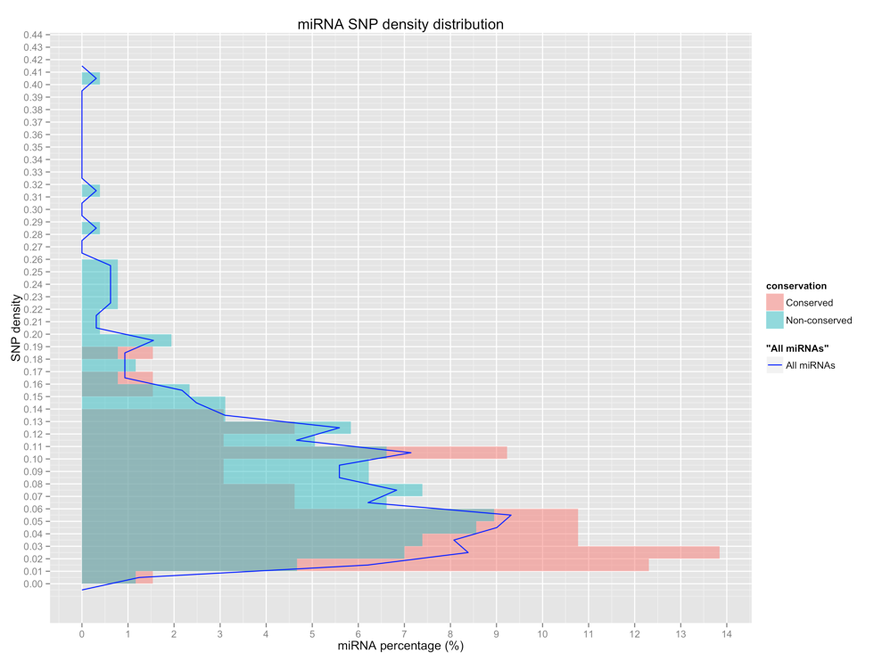



Illustration:

1. First 2 graphs are plotting query against 3K Rice SNP-seek database; while 1st graph takes miRNA count as X axis, 2nd graph takes miRNA percentage as X axis;
2. Last graph is published in *Rice* journal.

Summary:

Apparently, we have obtained more SNPs than they, so our the miRNA SNP density is relatively higher than that of theirs.

1. In total, most frequent SNP density range is 0.05~0.06; among non-conserved miRNAs, the most frequent SNP density range is 0.05~0.06 also;
2. While among conserved miRNAs, the most frequent SNP density range is 0.02~0.03.